Test Case: runTestMultipleTimes
Step 1 - Enter username and password and click to button Enter : Credentials Entered
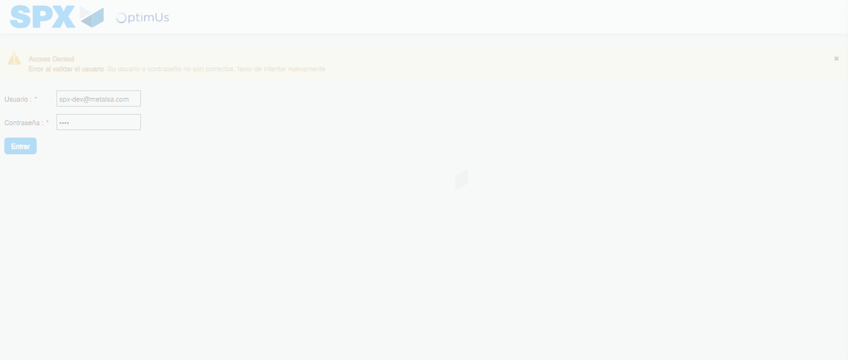Image file-name: QC_Testing-runTestMultipleTimes-nov. 20 2025, 02 20 21 p. m.

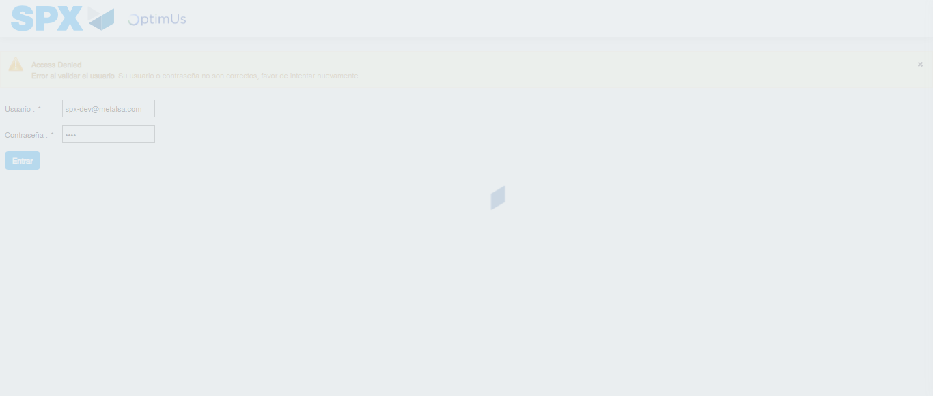Image file-name: QC_Testing-runTestMultipleTimes-nov. 20 2025, 02 20 22 p. m.

Step 2 - Select to UEN and Access to Administrador Roles Menu: UEN Correctly selected and Correct access
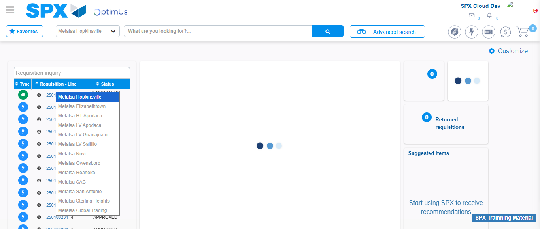Image file-name: QC_Testing-runTestMultipleTimes-nov. 20 2025, 02 20 24 p. m.

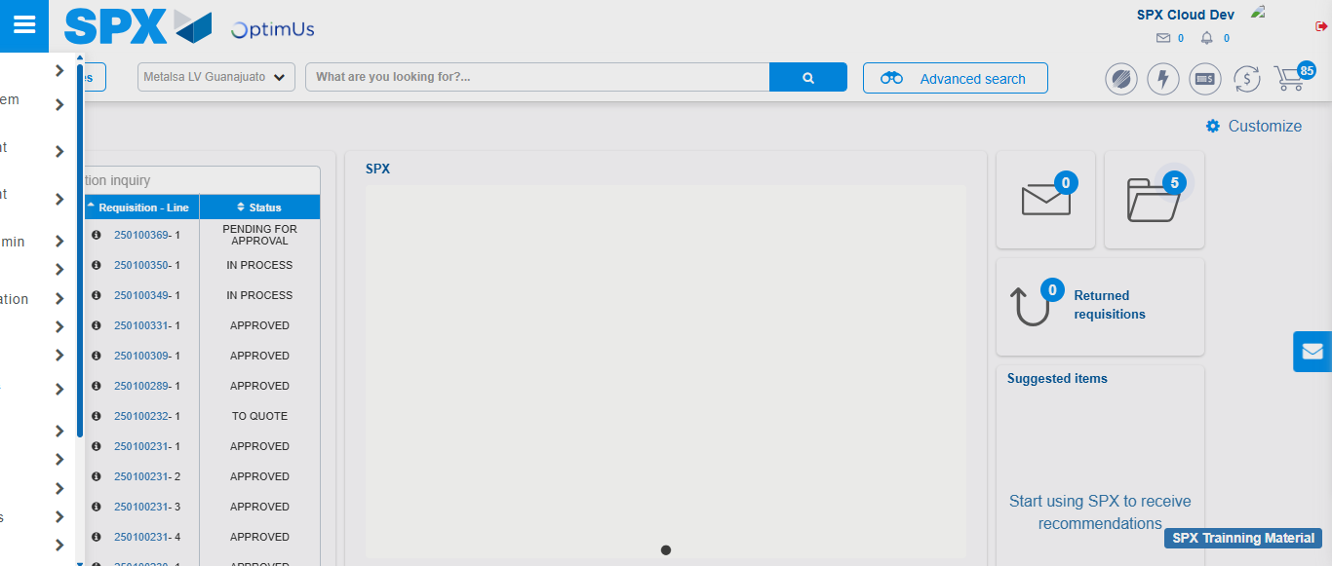Image file-name: QC_Testing-runTestMultipleTimes-nov. 20 2025, 02 20 25 p. m.

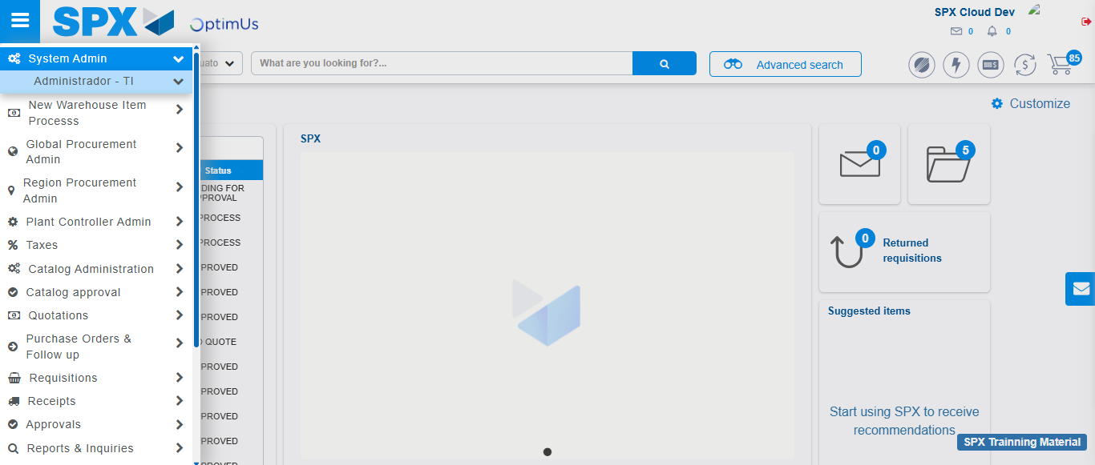Image file-name: QC_Testing-runTestMultipleTimes-nov. 20 2025, 02 20 26 p. m.

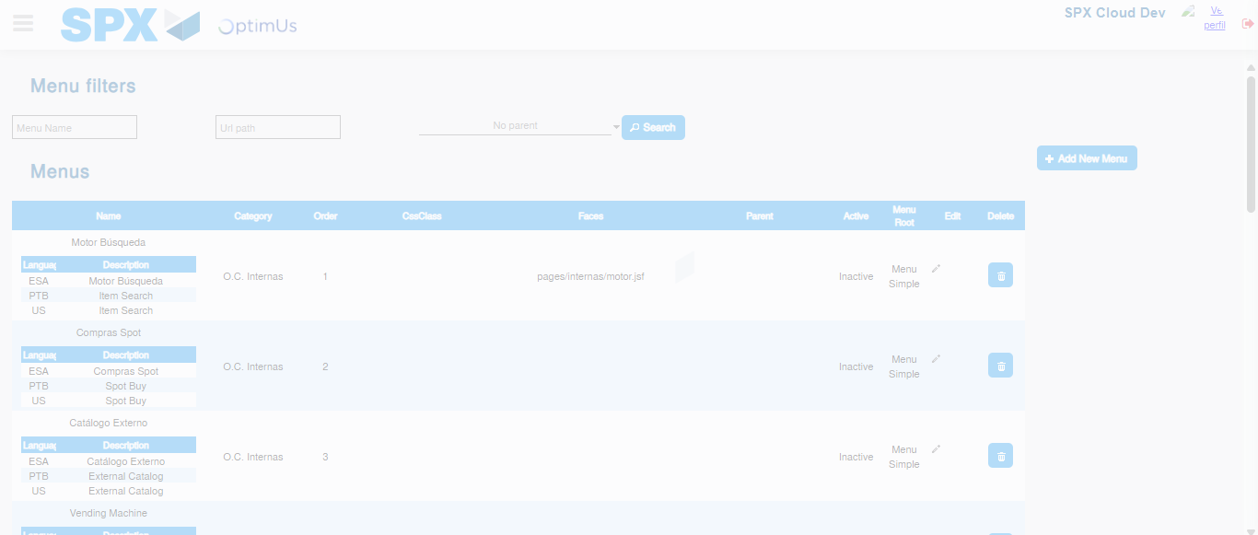Image file-name: QC_Testing-runTestMultipleTimes-nov. 20 2025, 02 20 28 p. m.

Step 3 - Perform a search with the URL Path filter: Successful search
Image file-name: QC_Testing-runTestMultipleTimes-nov. 20 2025, 02 20 28 p. m.

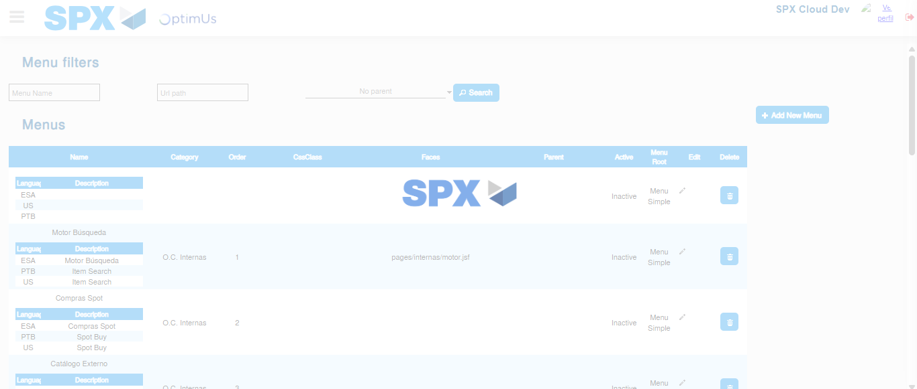Image file-name: QC_Testing-runTestMultipleTimes-nov. 20 2025, 02 20 31 p. m.

